

Lyft/Uber Comparison Application

User Guide for Front End-end Clients

URL: <https://taxicompareapp.azurewebsites.net/>

Developers for this App:

Kar Ho Tan,

Mark Wang,

Leron George

December 9, 2018

**Revision History**

|  |  |  |  |  |
| --- | --- | --- | --- | --- |
| **#** | **Date Updated** | **Updated By** | **Version** | **Overview of Updates Made** |
| 1 | *12/08/2018* | *Leron George* | *Final* | *Creation of document* |
| 2 | *12/09/2018* | Mark Wang | *Final* | *Reviewed document* |
| 3 | *12/9/2018* | Kar Ho Tan | *Final* | *Reviewed document* |

***Reviewers / Developers***

|  |  |  |  |
| --- | --- | --- | --- |
| **Reviewer** | **Role** | **Reviewed On** | **Comments** |
| Kar Ho Tan | Developer/QA | 12/8/2018 |  |
| Mark Wang | Developer/QA | 12/9/2018 |  |
| Leron George | QA/Design and Documentation/Presentation | 12/9/2018 |  |

Contents

Start Up Home Page 4

Page – Requesting Login 4

Page – Register/Create New Account for Login – 4

Login Start up Page 5

Page – Taxi Price Compare Form – Initial Landing Page 6

Page – Search return Page 7

Page – Order History 8

## Start Up Home Page

The Application landing page directs the user to create an account by registering or login with an existing user name and password.

### Page – Requesting Login

Accessing the Url: <https://taxicompareapp.azurewebsites.net/> Will allow you to land on the home page of this application

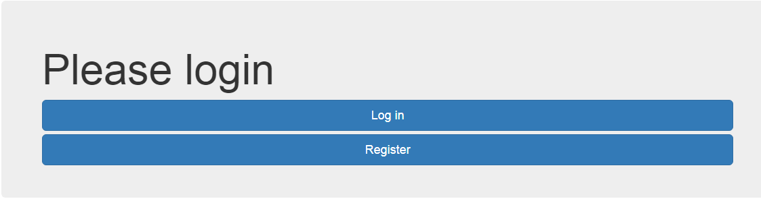

## Page – Register/Create New Account for Login –

For first time users please click on the ‘***Register’*** button which should re-direct you to the Register Form shown below to proceed further. If the user has entered a valid (formatted email) and entered password and confirmed it, they will be taken to the website Taxi where they can continue to enter locations A and B to get feed-back in relations to their desired destination.

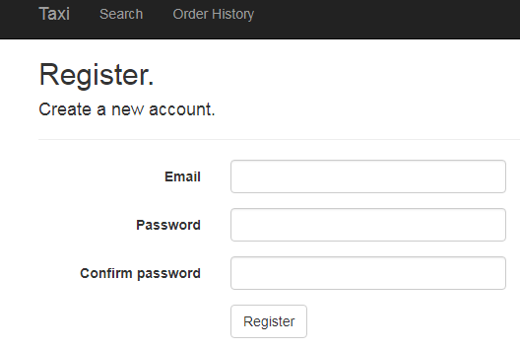

## Login Start up Page

If a user has already created an account and is a returning user, they can click on the ‘***Login***’ button that will simply ask them to enter their correct email and password that was originally created, if this is not successful, they will get error telling them to try again. Once this is successful, they will be directed to the taxi form where they can enter their desired locations for feedback. Additional if the user accessed this login form and have not yet created an account to our site, they can simply click on the ‘***Register as a new user’*** which will then re-direct them back to the register new account form.

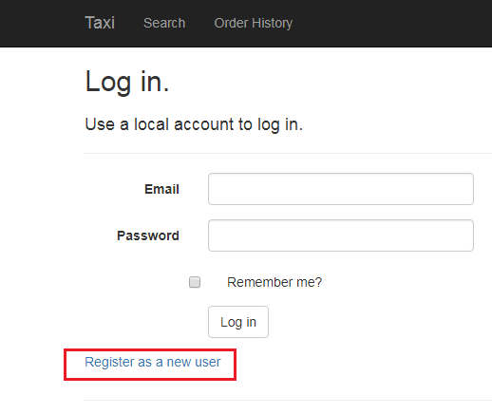

### Page – Taxi Price Compare Form – Initial Landing Page

Once the user has log in successfully either by completing a new registration or initially clicking on the ‘***log in***’ they should be directed to the form with banners showing (Taxi, Search order history) to the right hand corner of the form they should see their correct email address displaying their correct credentials; this is a feature f Azure Cloud that has authenticated the client through our login database. The landing page already has pre-populated from and to coordinates, however the user can simply edit/delete these locations and entire their desired location for price check.

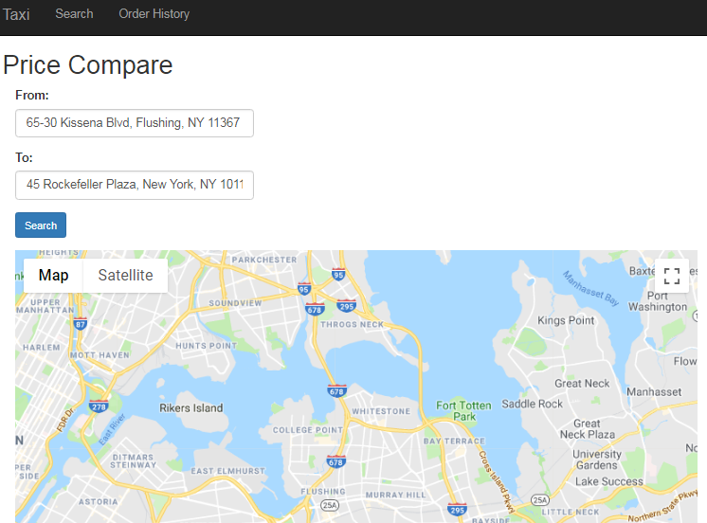

### Page – Search return Page

The user can enter their desired from and to locations and click on the ‘***Search’*** button, this should update the Google Map with pointers showing A and B and the shorting mapping between these two points according to live data returned. Once the user scrolls down to the below of the page once it loads briefly, they will be able to see the prices of all type of cars services by car type and high/low price sorted from most expensive to least, the user can enter specific criteria in the search menu or just tab through the page to find the best available at this time to proceed with their order

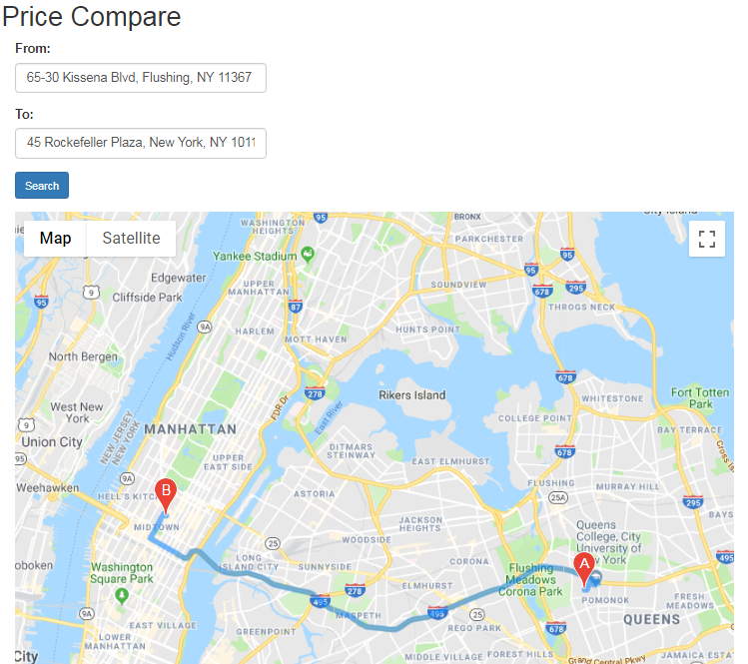

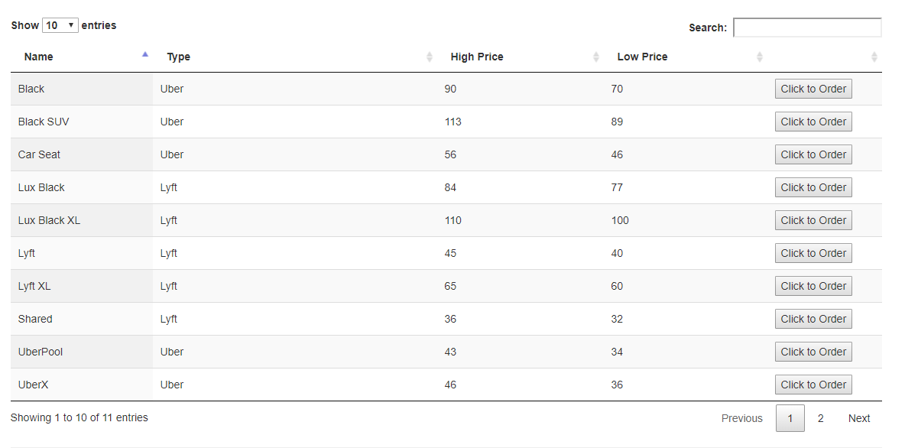

The Page displays the full results of the prices for the location between points A and B and displays the price for each available type of Taxi. The user can navigate through pages selecting the next marker at lower right hand of the page, the user can also use the search window that allows them to filter their search criteria.

### Page – Order History

Once the user clicks on the ‘***Click to Order’*** button, the application will display a successful response and the user can navigate to the order history page to view all recent transactions under their profile. The User can use this information for reporting purposes.

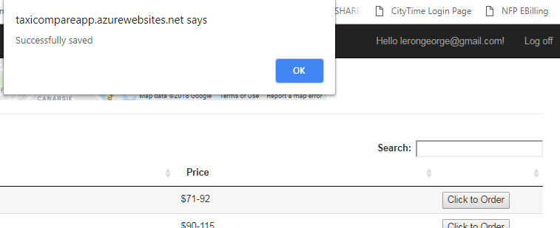

The user can see the entire order history of their inventor; it is a repository o f all their prior orders with the services they choose, and the coordinate address along with the price and distance, user copy and paste to excel and perhaps run reports on for analyst. The information is stored per user and once you log in you are only able to see this information per your user account.

